Automatic Recirculation Valve – Data Sheet
Part 1 - Company Information
Name/Title: |  |  | Company Name:
Street: |  |  | City:
Country: |  |  | Post Code:
Telephone: |  |  | E-Mail:
Part 2 - Order Information
General: | Quantity: |  | Application:
 | Tag No.: |  | Project Name:
 | Valve Model: 78PS Automatic Recirculation Valve |  | Project No.:
Part 3 - Valve and Process Information
Valve Information: | Valve Inlet Size (DN/Inch): |  | Valve Inlet Pressure Rating:
 | Valve Outlet Size (DN/Inch): |  | Valve Outlet Pressure Rating:
 | Bypass Outlet Size (DN/Inch): |  | Bypass Outlet Pressure Rating:
 | Materials Housing: |  | Materials Trim:
 | Installation: Vertical ☐ or Horizontal ☐
Process Information: | Process: | Liquid or Gas: |  | Fluid Vapor Pressure (barₐ):
 | Medium: | Op. Temp.: |  | Viscosity:
 | Density (kg/m³): | PED Fluid Group 1 or 2:
Pump Information: | Qmin (m³/h): | HM (m): |  | Suction pr. PV (bar/psi):
 | Q100 (m³/h): | H100 (m): |  | Backpress. P1 (bar/psi):
 | Qmax (m³/h): |  |  | Backpress. PN (bar/psi):
 | QBy (m³/h): |  |  | Differential pr. (P1-PN) (bar/psi):
Part 4 - Please Use the Chart Below to define the information required in Part 3
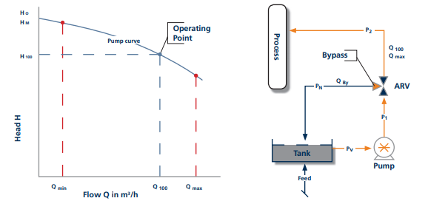
Notes:
Send To: SchuF Fetterolf E-Mail: valves@schuf.com Fax.: +49 6198 571200

